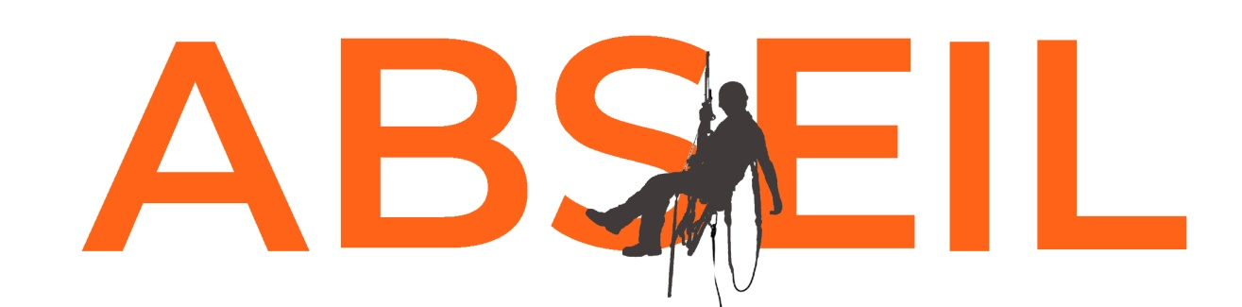
Registered charity no. 1017406

SPONSORSHIP FORM

5th October 2019

SPONSORSHIP FORM

Name:

Address:

Gift Aid information for sponsors

Gift aid allows Greenwich & Bexley Community Hospice to claim back the tax you’ve already paid on the money you donate.

If you’re a UK taxpayer, your donations could be worth 25% more to us, just by giving your full name, address, postcode and ticking the box – it’s that simple!**

Full Name | Home Address | Postcode |  |  |  |  |  |  |  | Pledged  amount | Amount received | Hear more* (please tick) | Gift Aid**
Total |  |  |  |  |  |  | £

Turn every £10 donation into £12.50 for your local Hospice,
at no extra cost with Gift Aid.**

Full Name | Home Address | Postcode |  |  |  |  |  |  |  | Pledged  amount | Amount received | Hear more* (please tick) | Gift Aid**
Total |  |  |  |  |  |  | £

Gift Aid
** I confirm that I am a UK Income or Capital Gains taxpayer. I have read this statement and want to Gift Aid this donation and any donations I make in the future or have made in the past 4 years to Greenwich & Bexley Community Hospice. I understand that if I pay less Income Tax and/or Capital Gains Tax than the amount of Gift Aid claimed on all my donations in that tax year it is my responsibility to pay any difference. I understand the charity will reclaim 25p of tax on every £1 that I have given. I will notify Greenwich & Bexley Community Hospice if my name, home address or tax-paying status changes.

Keeping in touch
*We would love to stay in touch to tell you about the amazing difference that you’ve made, update you with the work we are doing and other ways to support. Please tick in the ‘Hear more’ column if you would like to hear from us by post. You can change your mind at any time: Call 020 8319 9230 or email fundraising@gbch.org.uk

