**Volunteer at**

**Young Ward**

**Volunteers**

**Programme**

**Interested in a career in medicine or healthcare?**

Are you interested in a career in

healthcare and looking for unique

and meaningful work experience?

If you are **17-24** **years old**, you can

volunteer at Greenwich & Bexley

Community Hospice.

Our **Young** **Ward Volunteers** commit

one evening a week, 4 pm to 8 pm to

volunteer on our Inpatient Unit,

supporting our Healthcare Assistants.

Over a **6 month programme**, there is

extensive training while working towards the Care Certificate qualification.

Limited places available on this popular programme, we reserve the right to close applications early.

**Closing date: Friday 22nd July.**

**Commences October 2022**

**Interviews will be arranged on application.**

**Striving to be an**

**Equal Opportunities Employer**

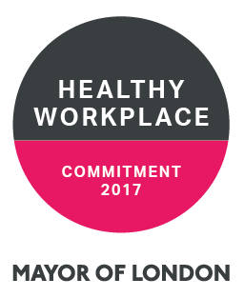

**Thank you for your support. For more information:**

**W: www.communityhospice.org.uk or E: youngvolunteers@gbch.org.uk**

ijn

Thank you for your support. For more information:-

[www.communityhospice.org.uk](http://www.communityhospice.org.uk) or youngwardvolunteers@gbch.org.uk

Greenwich & Bexley Community Hospice Limited. A company limited by guarantee. Registered in England and Wales No 2747475. Registered Charity No 1017406

